**CURRICULUM VITAE**

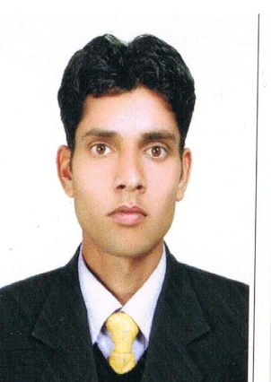**RAJEEV KUMAR**

VILL. KACHHREAR, P.O MUMTA

TEH & DISTT. KANGRA

HIMACHAL PRADESH (176047)

Contact No: - +91 9805021124, +917018050092

Email id: **- rajeevchoudhary24@gmail.com**

**CAREER OBJECTIVE**: - To work in an organization that offers challenging and dynamic work environment, to play a significant role in its growth and develop myself as a perfect Hotelier.

**EDUCATIONAL QUALIFICATION:-**

|  |  |  |
| --- | --- | --- |
| **Class** | **Board** | **Stream** |
| 12th | HP Board | ARTS |
| 10th | HP Board |  |

**PROFESSIONAL QUALIFICATION:-**

* B.Sc. in Hotel Management and Catering Technology from H.I.H.T. Shimla affiliated to P.T.U. Jalandhar Punjab

**INDUSTRIAL EXPOSURE:-**

* 8 Days ODC in **Wild Flower Hall** (Sister Concern of Oberoi), Shimla
* 3 Days ODC in **Radisson Jass Shimla**, Shimla.
* 6 Month Industrial Training in **ALOFT HOTEL**(Starwood property) Chennai
* Worked as room attendant in **Snow Hermitage Resorts** Jan 2013 to Oct 2013
* Worked as HK GSA in **BRYS FORT HOTEL JAISALMER** NOV2013 to DEC 2014.(BRYS GROUP)
* Worked as senior GSA in **HOLIDAY INN AMRITSAR** DEC 2014 to DEC 2016 (IHG GROUP)
* Now working as housekeeping supervisor in **Pride Surya Mountain Resorts Dharamshala** (Unit of Pride Group) Jan 2017 to till date.

**Job Profile:**

* Responsible for smooth operation of the floor assigned.
* Responsible for the performance of floor boys.
* Supervise Room Attendants
* Organizes and facilitates the room making process.
* Daily allocation of rooms and deep cleaning tasks to team members.
* Responsible for the cleanliness of guest rooms, corridors and heart of the house area of the floor.
* Checks the occupied and departure rooms, giving special attention to guest needs.
* Ensures that the entire operation is performed as per the laid down standards.
* To organize immediately the guest needs under intimation to EHK/Executive.
* Manage guest requests, including VIP amenities and communicating them to the relevant team members
* Routine inspection of guest bedrooms to ensure they meet standards.
* Aware of all room categories and amenities.
* Achieve positive outcomes from guest queries in a timely and efficient manner
* Carry out lost and found procedures.
* Report maintenance issues to Maintenance/Engineering Department.
* Assist Housekeeping Manager with training requirements.
* Represent the needs of the team to others in the hotel.
* Comply with hotel security, fire regulations and all health and safety legislation.
* Assist other departments wherever necessary and maintain good working relationships.

**Technical Qualification:**

* Basic knowledge of computer
* I.D.S. software/ Opera

**PREFERENCE**

* HOUSEKEEPING

**HOBBIES**

* Cricket, listening light music & Interacting with people.

**Strengths:**

* Leadership Qualities, Smart Worker, Sincere.
* Passion on learn new things.
* Confidence, adaptability nature.

**Achievement-**

* Achieved the Best trainee Award
* Selected best employee of the month(July 2015)
* Promoted to Tr. supervisor (Holiday Inn) April 2016
* Achieved Brand hearted service Award ( Holiday inn )

**PERSONAL PROFILE**

* Father’s Name : Sh. Punnu Ram
* Gender : Male
* Nationality : Indian
* Languages Known : English & Hindi

**Declaration:**

I do hereby solemnly affirm and declare that the particulars of information and facts stated herein above are true, correct and complete to the best of my knowledge.

**Date: - _____________**

**Place: - _____________** (**RAJEEV KUMAR)**